Pointer

Basic of Pointer

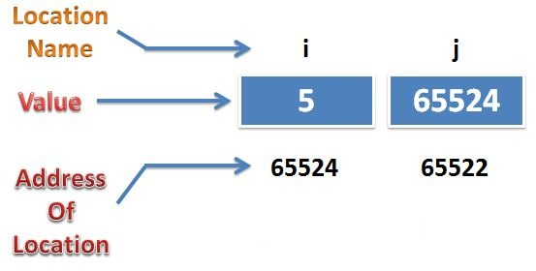

Where

i is an ordinary variable

j is a pointer variable

continue….

In the basis of DOS Base Architecture when C Program is RUN it takes 64 Kilobytes memory in RAM.

64Kb = 65536 bytes ( 64 * 1024 = 65536 )

This 65536 bytes assign no. 0 to 65535.

This assign value is called : sequence no. or address (logical address)

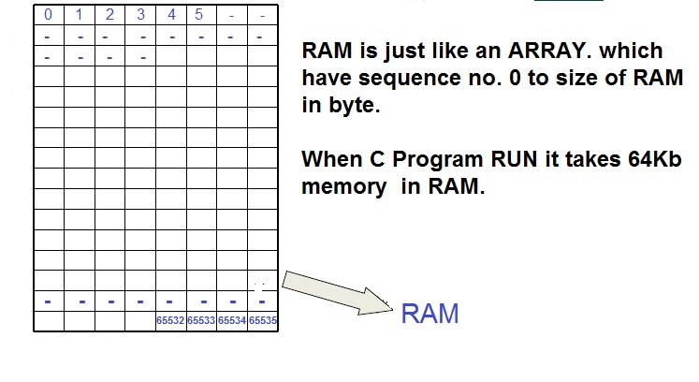

Continue…

Pointer is a variable that contains address of another variable of same data type.. ( e.g : ptr)

Pointer Variable (e.g : *ptr)

In C declaration if the variable name is preceded by asterisk or * then such a variable is called pointer variable.

Pointer Declaration :

Ex: int *ptr ;

Where ptr is the name of variable. The * informs the compiler that we want a pointer variable. The int say that we are using pointer variable which will actually store the address of an integer value.

This * Operator has two meanings in C language while declaring this means that a pointer variable is created, where as in other cases this * operator means value at Operator.
Example
Int *y // Pointer Variable
*y // Value at address y
Note : above we can see that * has two meaning in different context. That’s why C language is context sensitive language.
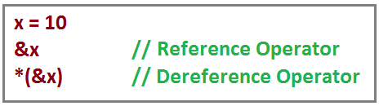

Note:

Pointer always use two bytes in memory.

Always store the base address of variable.

Pointer always point or store the address of block which have same type as pointer have.

Pointer type should be necessary.

Remember :

When put an ampersand (“&”) in front of a variable it will return address of that variable.
Ampersand ( &) called address of operator.

When put an asterisk (“*”) in front of a address variable(&a or ptr) it will return value of that variable.

Asterisk (*) called value at operator.

Pointer always return containing address ( e.g : printf(“%u”,ptr); ).

Base Address
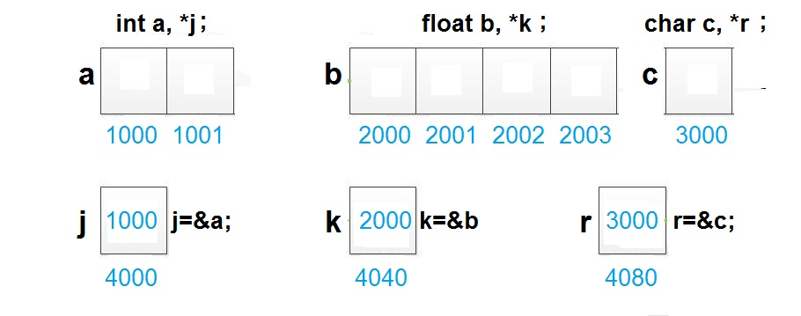

Example :

int var=50 , * ptr ;

ptr= &var ;

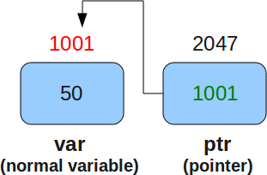

Example :

main()

{

int var=50, *ptr , *p ;

ptr= &var ;

*p = 6 ;

printf ( “ %d ”, var ) ; // 50

printf ( “ %d ” , ptr ) ; // 1001

printf ( “ %d ” , *ptr ) ; // 50

printf ( “ %u ” , &var ) ; // 1001

printf ( “ %u ” , &ptr ) ; // 2047

printf ( “ %u ” , *&ptr) ; // 1001

printf ( “ %d ” , *p ) ; // 6 (6 store at invalid address, wild pointer)

printf ( “ %u ” , p ) ; // garbage address or invalid address

}

Note : Address always return with format string %u

Error Occur at time of Declaration
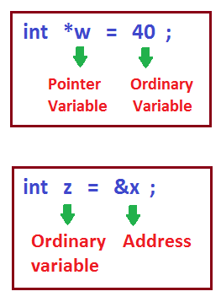

Objective

Extended Concept of Pointers

Pointer’s Arithmetic

Application of Pointers

Extended Concept of pointers
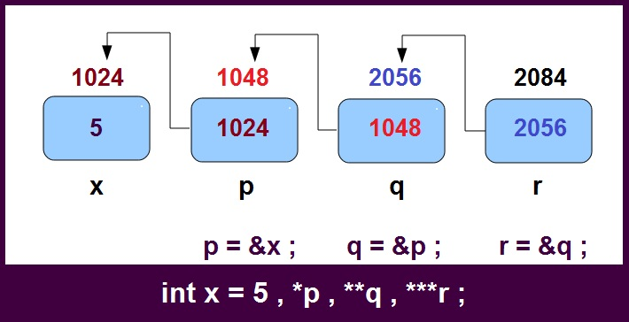

Note : Number of Asterisk (*) represent the level of pointer.

“Always greater level of pointer contain/ hold the address of less than 1 level of pointer”

Example :

void main ()

{

Int x =5 , *p , **q , ***r ;

P = &x ;

q = &p ;

r = &q ;

printf ( “ %d ” , x ) ; // 5

printf ( “ %u ” , p ) ; // 1024

printf ( “ %u ” , q ) ; // 1048

printf ( “ %u ” , r ) ; // 2056

printf ( “ %d ” , *p ) ; // 5

printf ( “ %d ” , **q ) ; // 5

printf ( “ %d ” , ***r ) ; // 5

getch ( );

}

Addressing Mode and Final Conclusion
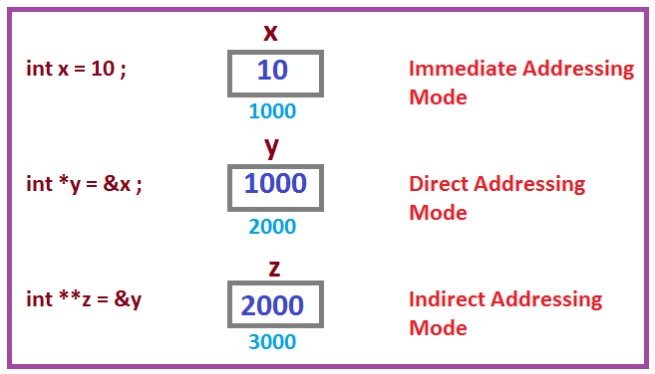

Some Important Conclusions.

Difference between

int x ;

OS thinks value is going to be stored.

int *x

OS thinks addresss is going to be stored

Error will be generated

int * w = 40 ;

int w = &x ;

In int *y

variable name cannot be *y, it name is y.

Variable , which contains address is called pointer variable.

Pointer Arithmetic

We cannot add, multiply or divide two addresses ( Subtraction is Possible)

Example :

void main()

{

int a, b , x, y, z ;

int *p, *q ;

p = &a ;

q = &b ;

x = p*q ;

y = p / q ;

z = p + q ;

Or

x = &a * &b ; // error

y = &a / &b ; // error

z = &a + &b ; // error

}

Remember:

The name of array contains base address of array. Ex : a

a[4] means *(a+4)

value of a[4] is a value of *(a+4)

We cannot multiply an integer to an address and similarly we cannot divide an address with an integer value.:

Example :

void main ()

{

int x, y, m, n ;

float a, b ;

float *p, *q ;

p = &a ;

q = &b ;

x = p * 5 ; // &a * 5 ;

y = q * 6 ; // &b * 6 ;

m = p/2 ; // &a / 3 ;

n = q / 3 ; // &b / 4 ;

}

We can add or sub or subtract integer to an address ( return address)

Example :

int x , *p ;

p = &x ;

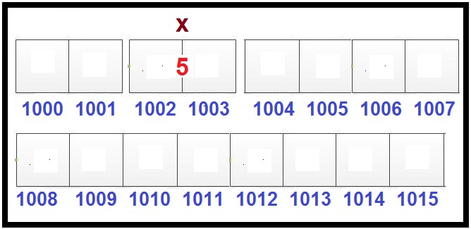

p + 1 ; // 1004 ( return next block base address of same type)

p - 1 ; // 1001 ( return previous block address of same type)

Note: That’s why we declare type before pointer variable which instruct to os that how many block will go ahead. e.i : in int 2 byte, float 4 byte and char 1.

Formulae :

Pointer + n = Pointer + sizeof (type of pointer ) * n

Example :

void main()

{

int a , b ;

int *p , *q ;

p= &a ;

q = &b ;

p = p + 1 ; // p = p -1 ;

q = q - 1 ; // q = q -1 ;

}

Note : they return address so must be store in pointer.

We can subtract to addresses of same type which have same level of pointer.

Formulae :

Pointer1 – Pointer2 = Literal Subtraction / sizeof( type of pointer)

Example :

#include<stdio.h>

#include<conio.h>

void main()

{

int x , y , z ;

float a, b , c ;

float *p , *q ,*r ;

clrscr();

p = &a ;

q = &b ;

r = &c ;

x = p – q ; or // x = &a - &b ;

y = p – r ; or // y = &a - &c ;

z = r – p ; or // z = &c - &a ;

printf ( “%u” , p ) ;

printf ( “%u” , q ) ;

printf ( “%u” , r ) ;

printf ( “%d” , x ) ;

printf ( “%d” , y ) ;

printf ( “%d” , z ) ;

getch ( );

}

Suppose we have float type variable

int a, b, c ;

int which address of

a is 65522

b is 65518

c is 65514

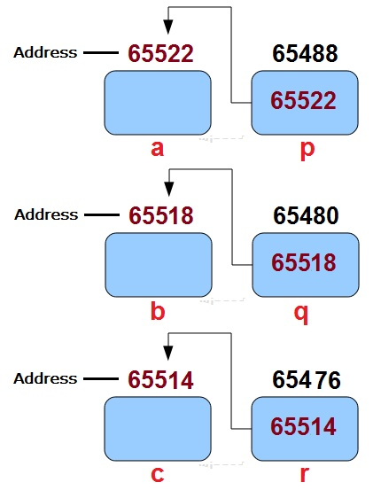

p-q => (65522 – 65518) / 4 => Literal Subtraction / Sizeof (typeof pointer) = > 1

p-r => (65522 – 65514) / 4 => Literal Subtraction / Sizeof (typeof pointer) => 2

p-q => (65514 – 65522) / 4 => Literal Subtraction / Sizeof (typeof pointer) => -2

Application of Pointer in C

In Function using Call by address.

In an Array ( we can print scan value through pointer)

In Dynamic Memroy Alloation

What is Wild Pointer

main()

{

int *p ;

printf(“%u” , p); // uninitialize pointer or called wild pointer

// print garbage value which means garbage address in any location

*p=4 // 4 store an unknown location or invalid location (free memory area)

}

What is NULL Pointer

Pointer which consist NULL value called NULL Pointer.

NULL is Predefined MACRO.

NULL assign means, pointer hold address 0 which also free memory area but we assume that they does not point to any space in memory.

Remember :

The macro "NULL" is defined in locale.h, stddef.h, stdio.h, stdlib.h, string.h, time.h, and wchar.h.

stddef.h this header file must be include in a program when we use NULL value.

stddef.h - standard type definitions

int *p= NULL ;

Solution for Wild Pointer Problem

Valid Address are the reserved addresses in Memory by you for your requirment in your Program.

Dangling Pointer
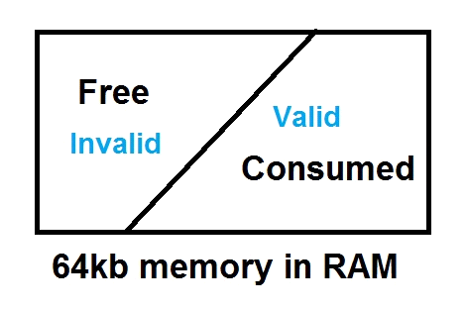

When a program is hold invalid address which before a Valid address in a program. Or when pointer hold the valid address which convert into invalid address

What is Dangling Pointer in C language

Example 1:

void fun(void);

main()

{

fun();

}

void fun()

{

int *p;

{

int x=5;

p=&x;

.........

.........

} // After this block is end , p point invalid address ( address of x)

}

Thumb rules is that After use of pointer , assign NULL value in that pointer in current scope

NULL is Predefined MACRO.

NULL assign means, pointer hold address 0 which also free memory area but we assume that they does not point to any space in memory.

Example 2

void main()

{

int *ptr = fun();

}

int* fun()

{

int a=5;

return &a;

}

As we know Activation Record of Functions is create in the Memory/RAM using organization of stack .

Memory is allocate when function call and run and deallocate when scope of function is end.

Thumb rules is that never return the address of a local variable from a function. If you have to return a address of a local variable, than make that variable static.

What is void Pointer Or Generic Pointer

void main()

{

void *p ;

int x ;

p=&x;

*(int*)p = 10 ; //type casting is necessary

printf ( “Address is %u and Value at that address is %d” , p , *(int*)p );

}

Continue…

void main()

{

void *p ;

float x ;

p=&x;

*(float*)p = 10 ; //type casting is necessary

printf ( “Address is %u and Value at that address is %f” , p , *(float*)p );

}

